Module 1.2 Assignment
“GitHub Repository Setup”
Andres Chavarria
10/25/26
GitHub Repository Link
https://github.com/andres-vc13/csd-325

GitHub Repository Screenshot
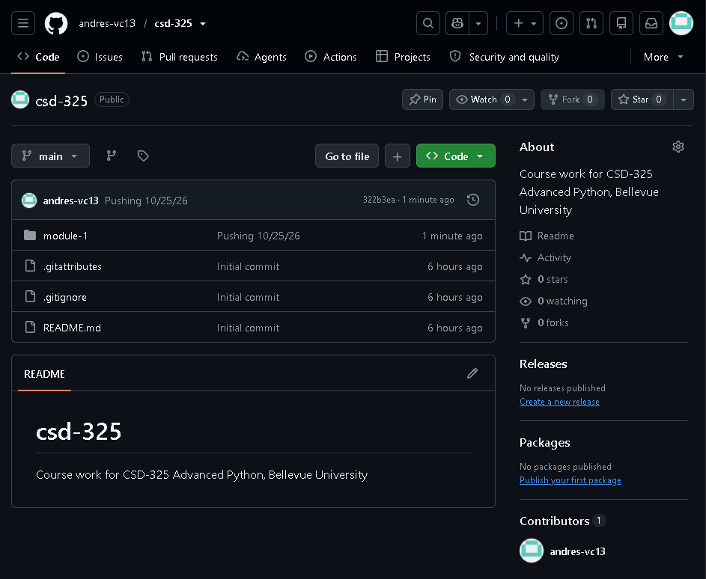

Local Directory Screenshot
